**INTELLIFAB MODULE**

1. This is how your process table will look at the end.

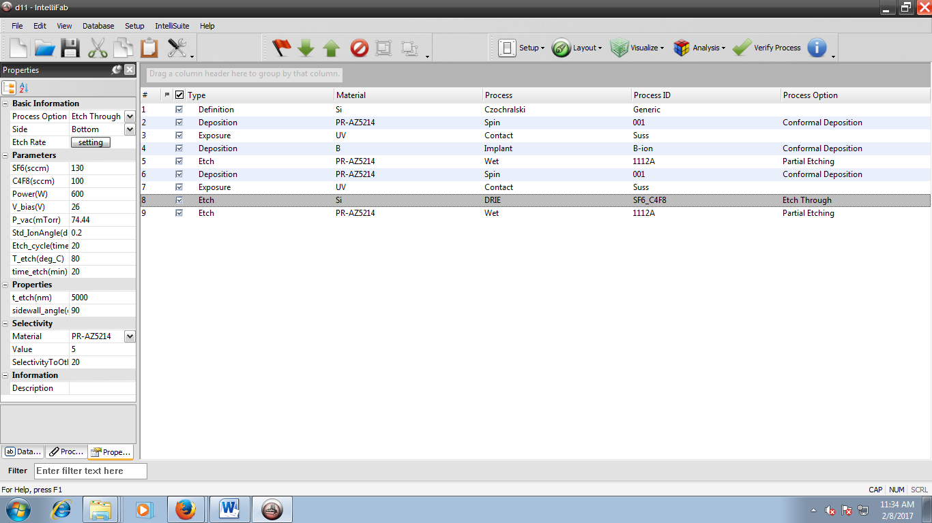

1. Click setup and Die size

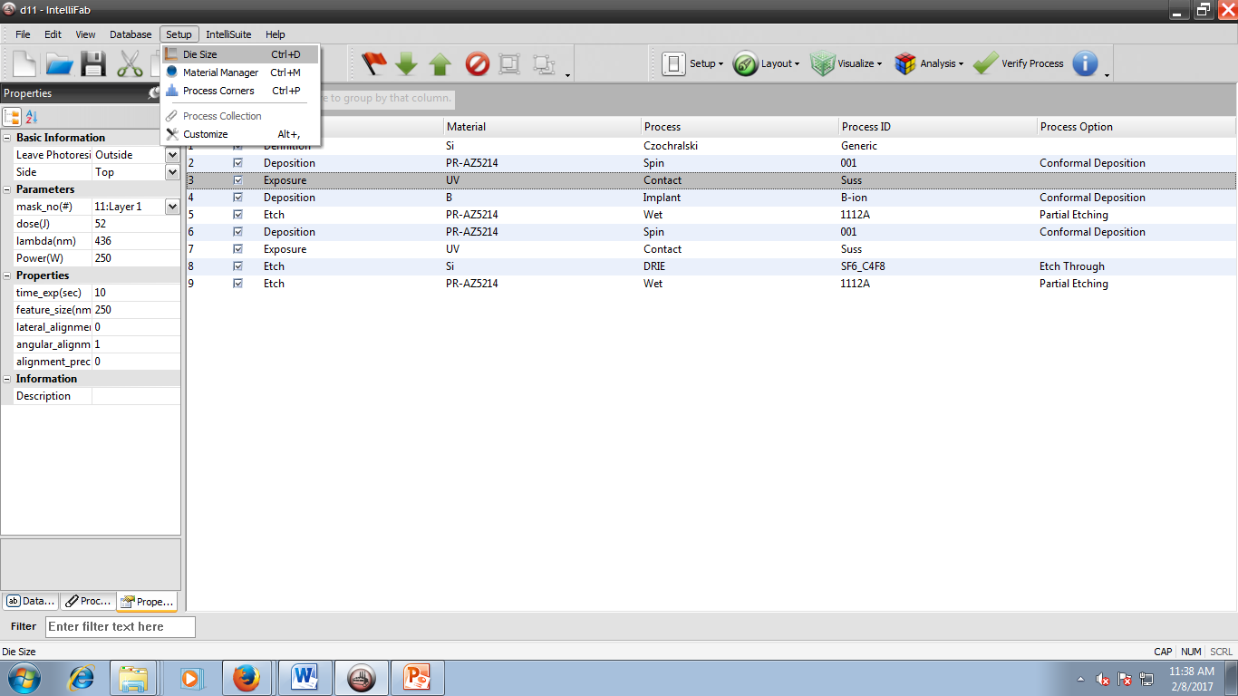

1. Select the required mask file and specify the die size. By default , the die size is for 1000 micro meter.

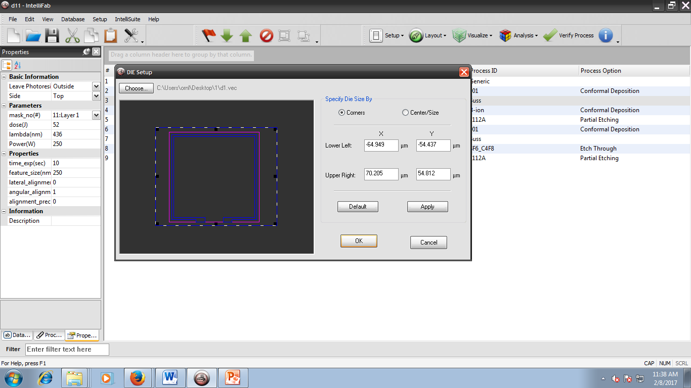

1. Follow the other steps as shown in step 1. At Step 3, make the following changes.

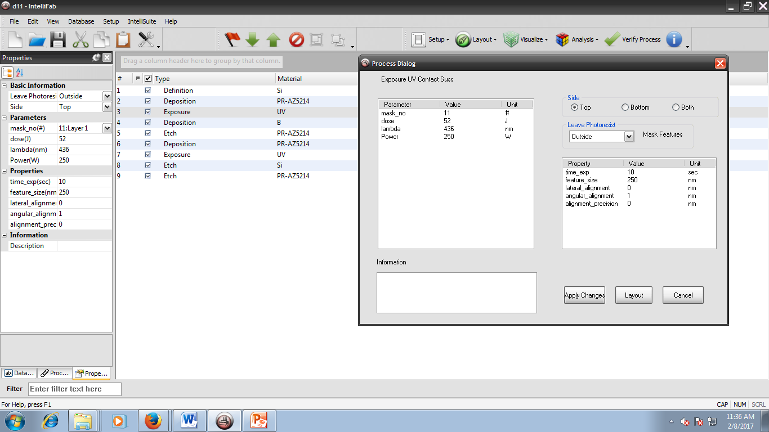

1. Similarly make the changes at step 6.

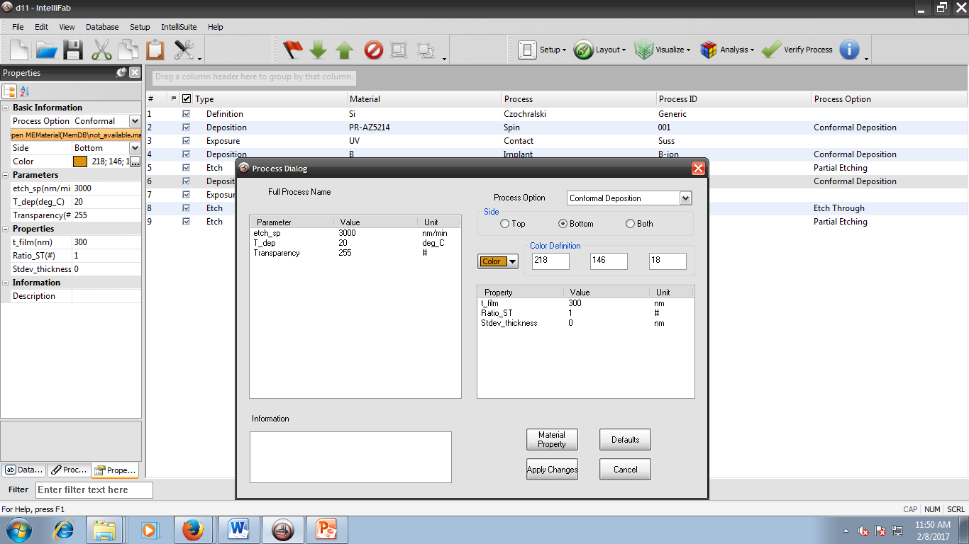

1. Similarly make the changes at step 7.

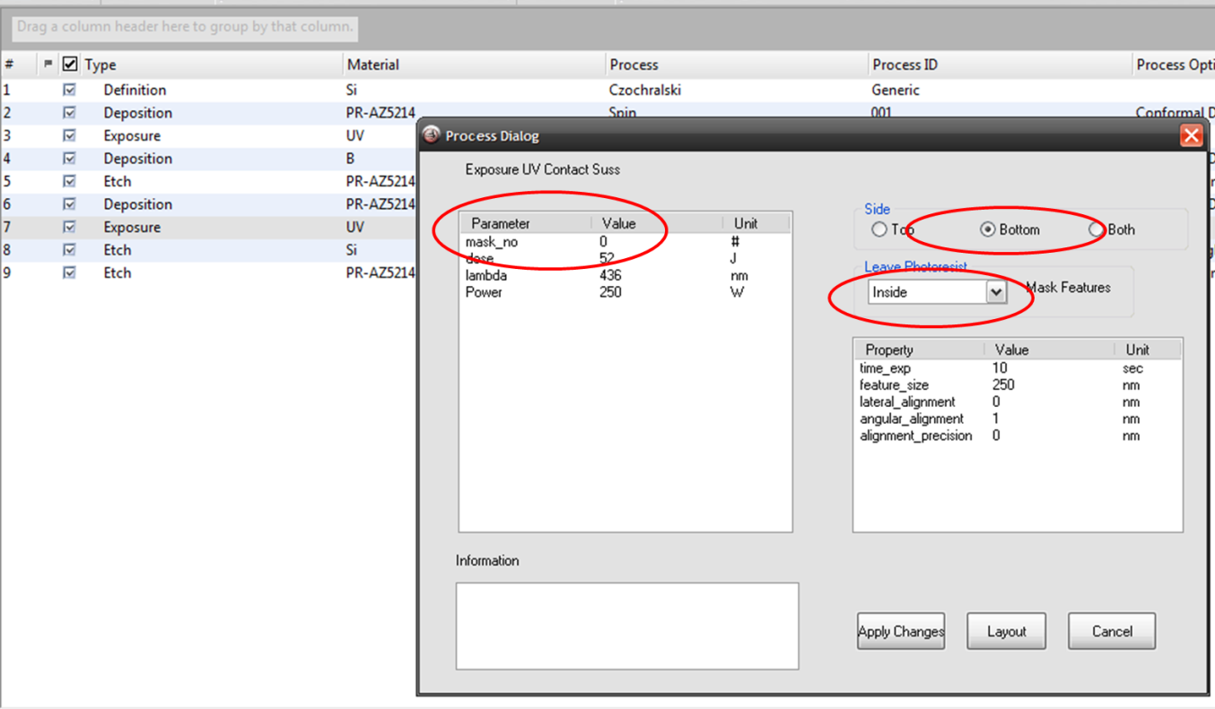

1. Make the following changes.

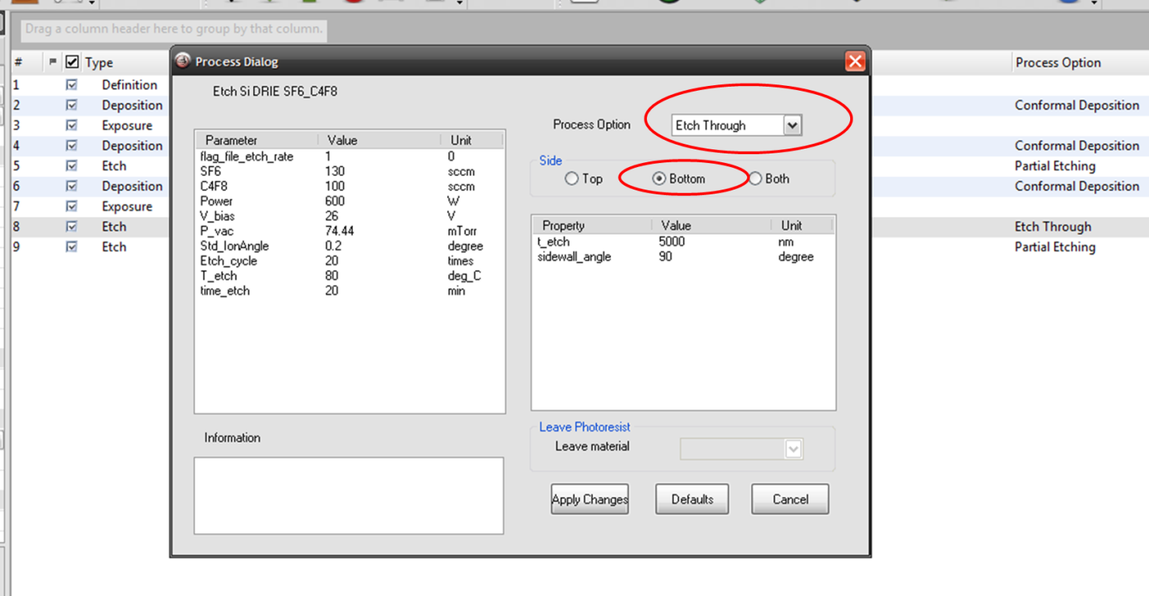

1. Click Visualize and select Visualize in FabSim. You can visualize the process flow at each steps.

